New EPO electronic tools: Mailbox and My Files

The EPO is pleased to announce the launch of two electronic tools which enable you to receive electronic notifications from the EPO, access your published and unpublished files and use our new self-service functions, all in a secure environment.
Mailbox is a single point of delivery for electronic communications from the EPO. Your company Mailbox allows for rapid notification of communications. The history is fully documented and essential information can be found fast. The company Mailbox is user-friendly with special folders having search and sort functions.
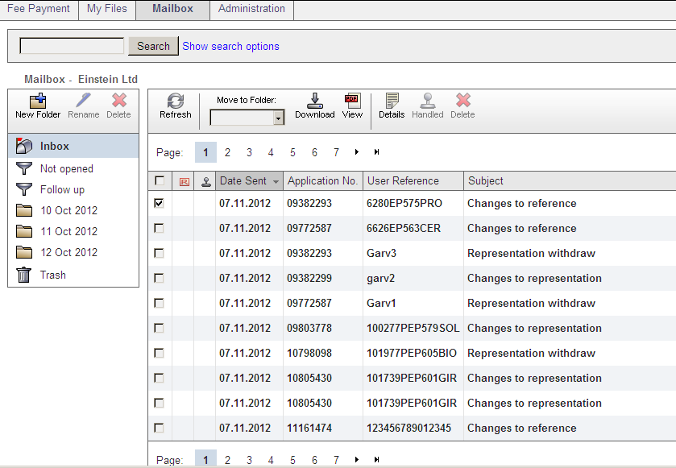
To start using the company Mailbox, you simply have to be a professional representative or association under Rule 152(11) EPC. One of the smart card users in your company has to become an Administrator and follow the steps required to activate the company Mailbox (see Mailbox Quick Reference Guide).

The company Mailbox will then allow you to receive selected notifications electronically. The notifications currently available are search reports, examiner communications and those listed in the link here. During the coming months the aim is to make the portfolio of electronic notifications as complete as possible.

Your benefits with Mailbox:

- no scanning needed

As companies become more automated, their workflows rely on documentation being electronic. The Mailbox facilitates this, while at the same time eliminating the need to scan documents.

- ten-day rule remains

Documents are received on or before the legal dispatch date, meaning that recipients benefit to the full from the ten-day rule. With respect to search reports, as is the case in the paper world, documents are dispatched immediately to the customer, meaning that recipients may even have a few days more than provided for by the ten-day rule.

My Files is an online service which provides secure access to the files for which you are, according to EPO data, the appointed representative. This cuts down on your administration and makes it easy for you to keep your portfolio up to date. You get access to your unpublished and published files as well as to complete file contents (including non-public documents). Additionally a new functionality enables you to manage your representation, i.e. to withdraw or re-assign representation and to change your user reference.
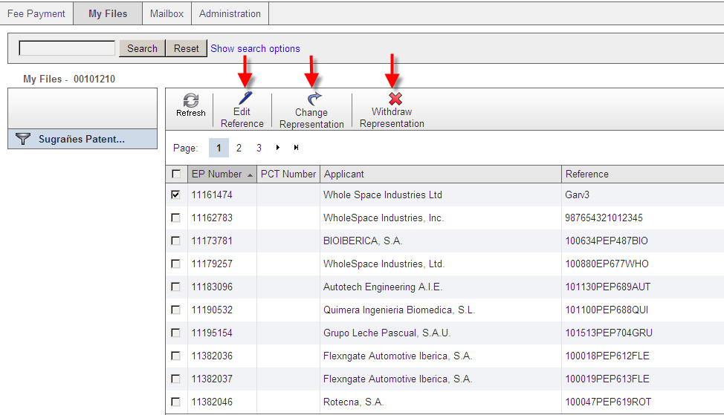

To log in to My Files, you have to be defined as a mailbox user, be a registered smart card user and use the smart card and PIN (see MyFiles Quick Reference Guide).

Your benefits with My Files:

- immediate and direct access to a whole range of communications

Not only do you receive documents on or before the date of dispatch in an electronic format, but MyFiles provides you with access to your non-published applications.

- list of your files

A dynamically produced list provides you with a searchable overview of all the files for which you are responsible.

- self-service functionality

Being able to withdraw or change representation electronically on the files that you own means that you can keep the records of your active files up to date, thereby enhancing the quality of your data and observing your duty of care to applicants.

Giving it a try
Why not run a pilot phase in your company, have an internal user test these tools and draw your own conclusions? You can deactivate Mailbox at any time if you so wish; deactivation is processed overnight which means that you will receive EPO notifications by postal mail again the following day.

Visit the online services and software access point on the EPO website www.epo.org
from which you can access the Mailbox and My Files.

